Level 1

# Purpose

The first level in game, show the genre and story background for players, easy to pass.

# Level map

### Prototype (digital)

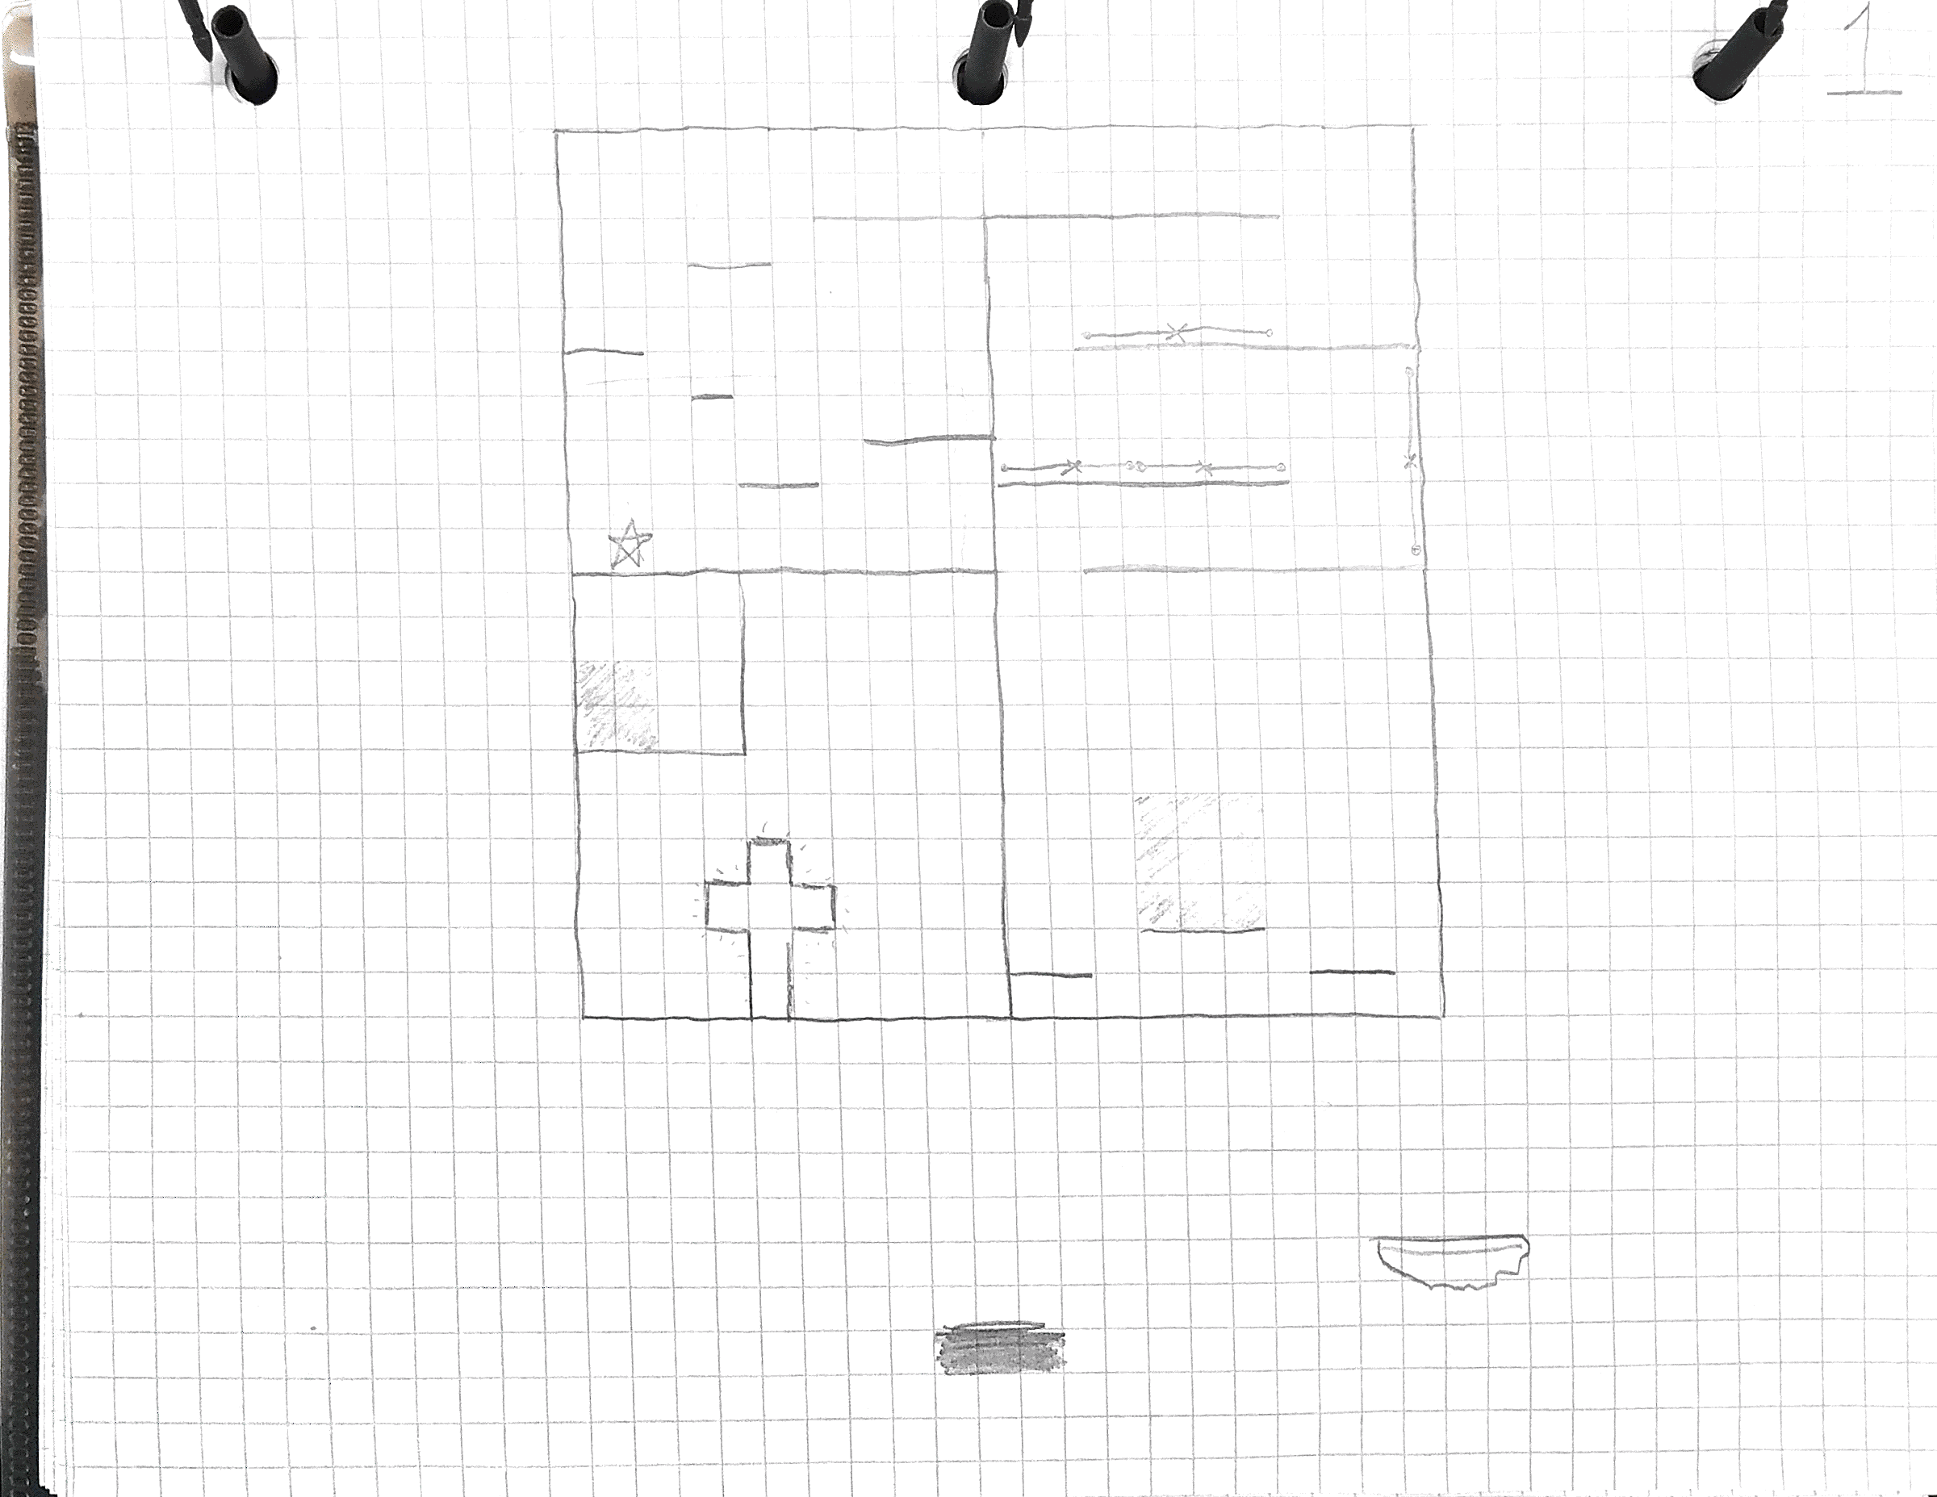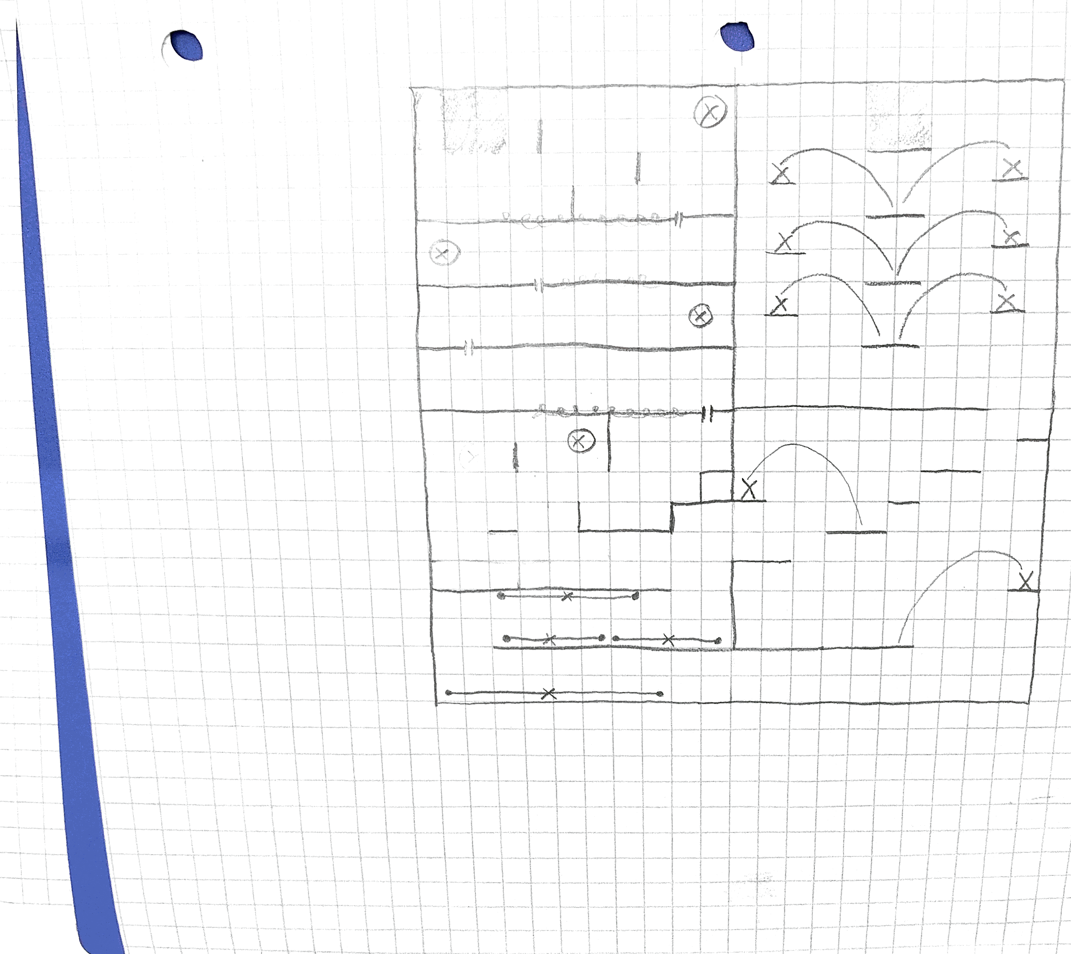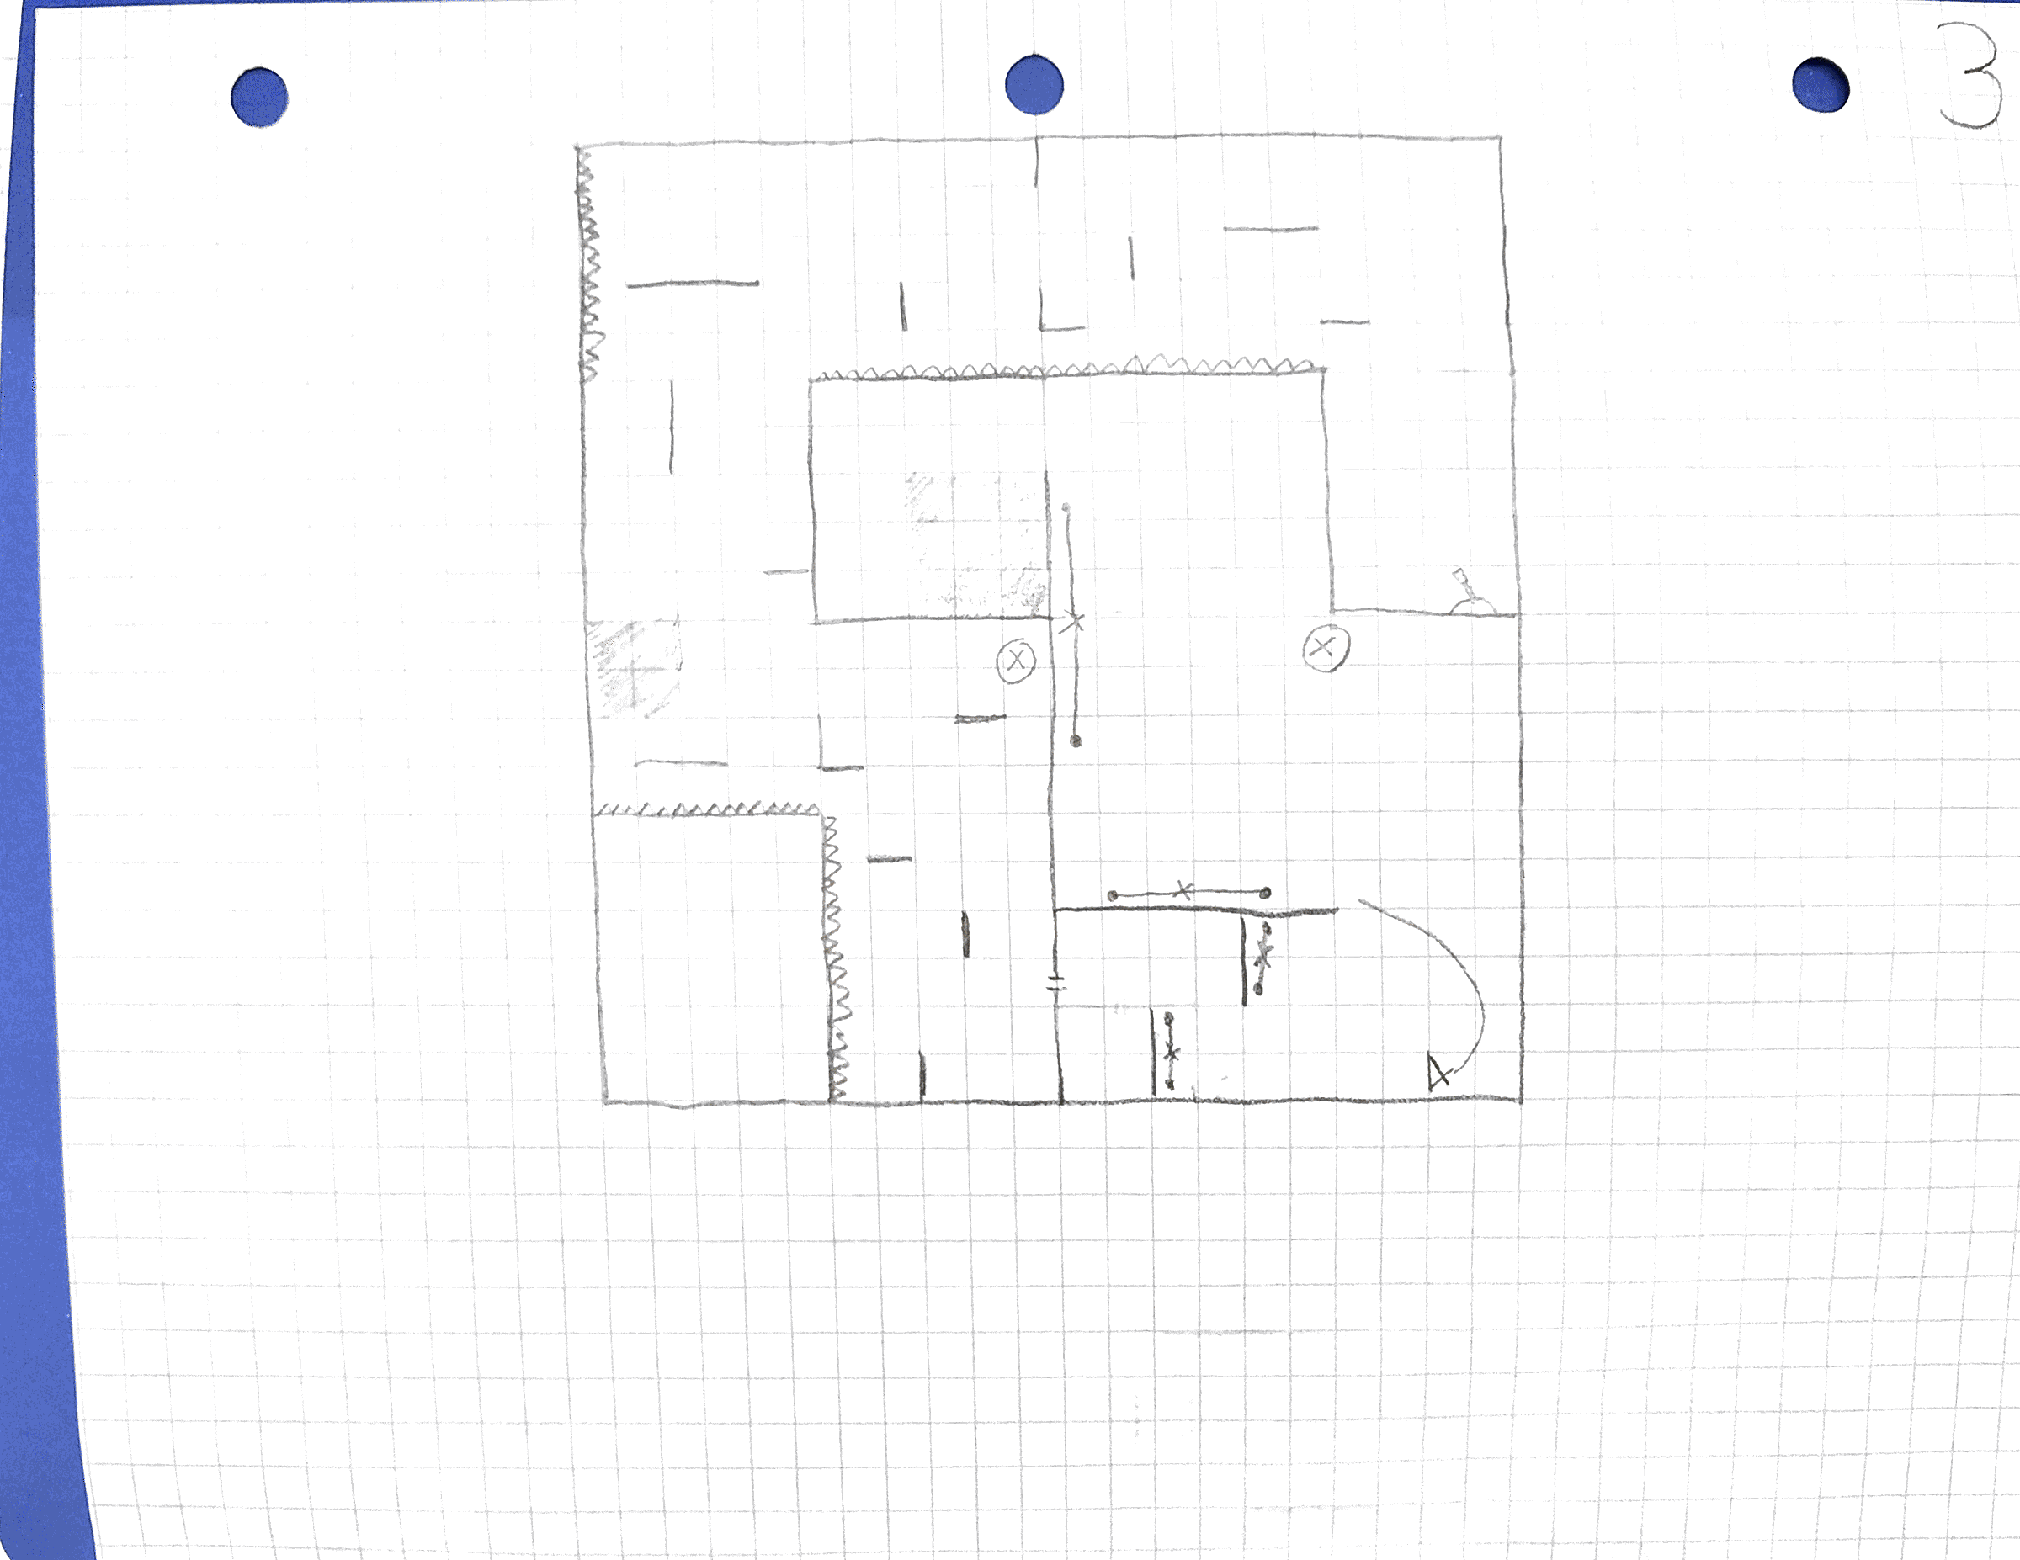

### Material for environment

(Here to explain what kind of material in level you want, try to show some reference)

**-platform:**

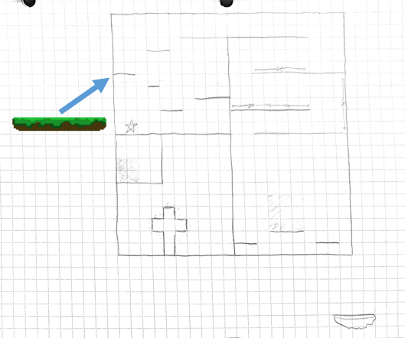

**-background wall:**

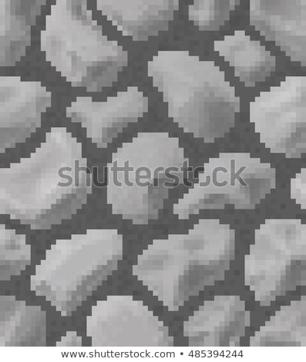

**…**

# Mechanic in level

-Traversing the Veil: This ability, usable in specific locations, will transport Raven from her current plane and into the next one. Pressing the F key while in these areas does the following: Freeze Raven in place; Begin Raven’s teleportation animation; Fade out current plane; Move next plane to current position and recolour; Finish Raven’s teleportation animation; Unfreeze

-Rotating The Planes: When certain objects (levers, etc.) are interacted with, a certain plane (color coordinated with the lever) in the level is rotated 90 degrees counter clockwise (or whatever Mike needs for his design). Enemies stay in the same place (eg. If they were on the floor, now they’re on the wall)

…

# Sound of environment

**-Goo**: Sticky dead water

…